Safe Dose Drug Journal

**Mission** **statement:**

Help you recover your **self**

The problem **Comorbidity**

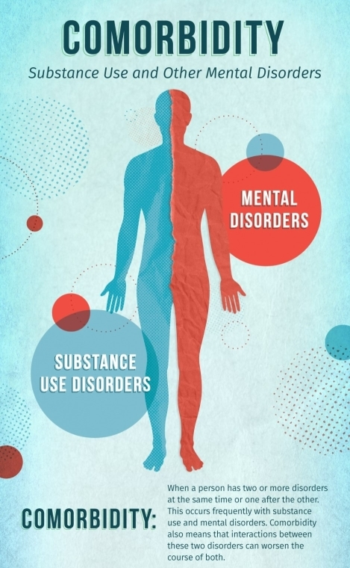

Almost a third of adults in the European Union aged 15-64, or around 97 million people, have used illicit drugs at some point in their lives.

Chronic use of some drugs can lead to both short- and long-term changes in the brain, which can lead to mental health issues including paranoia, depression, anxiety, aggression, hallucinations, among others.

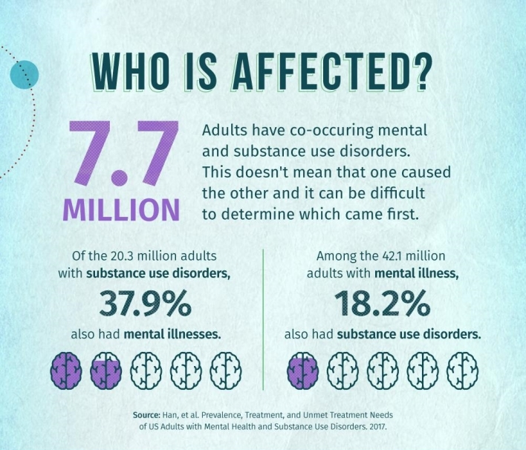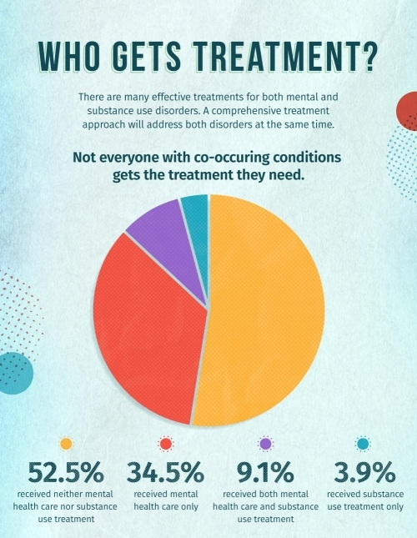

The Problem

Infographic by National Institute on Drug Abuse, “Comorbidity: Substance Use and Other Mental Disorders” (2018)

A community in which The product users can trust to find



information and help.

**1.** **Search** **for** **the** **substance**

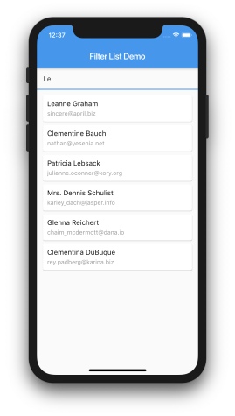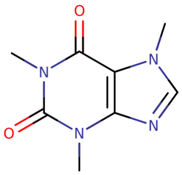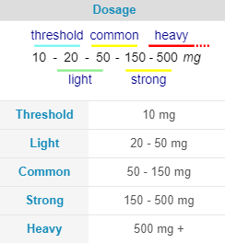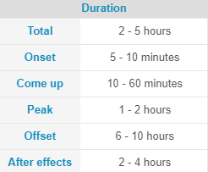

Caffeine

Psychoactive class: Stimulants

When you select it, you will receive basic **information** about it

The Product

**2.** **Choose** **the** **dose** **you** **are**

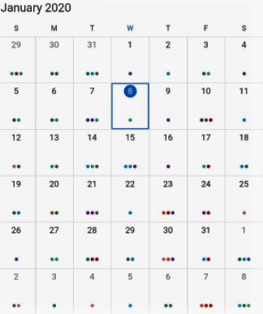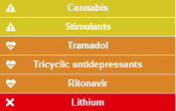

**taking** **and** **it** **will** **be** **added** **to**

**the** **calendar** Lysergic acid diethylamide (LSD) Interactions

Psychoactive class: Psychedelic

➔Interactions ➔Harm potential ➔Tolerance ➔Physical effects ➔Visual effects ➔Cognitive effects ➔Multisensory

effects

Cognitive Effects

● Hallucinations ● Psychosis

● Anxiety

● Thought loop

You will have information about dangerous **interactions**, as well as the **subjectives** **effects** and **potential** **side** **effects**

The Product

**3.** **You** **will** **be** **reminded** **of** **the** **risks** **to** **which** **you** **are** **susceptible,** **and** **you** **will** **be** **given** **advices** **that** **might** **save** **your** **life**

**4.** **You** **will** **always** **have** **help** **available** **one** **click** **away**

Alcohol & Amphetamines

Physiological dangers: ● Liver damage

● Arrhythmia ● Stroke

● Heart attack

Psychological dangers: ● Anxiety

● Psychosis

● Increased suicidal

thoughts

If you feel discomfort on your chest or dizziness do not hesitate to look for help

Suicidal ideation?

Total helplessness?

**Call** **an** **Ambulance**

**Call** **mental** **health** **helpline**

The Product

**5.** **Depending** **on** **the** **frequency** **and** **dosage** **of** **the** **drug,** **the** **user** **will** **be** **classify** **into** **one** **of** **the** **4** **stages** **of** **addiction**



**Stage** **1** **-** **Experimentation** ● To feel good — feeling of pleasure, “high” or "intoxication"

● To feel better — relieve stress, forget problems, or feel numb

● To do better — improve performance or thinking ● Curiosity and peer pressure

**Stage** **2:** **Regular** **Use** **&** **Abuse** Something that was once considered recreational or

temporary becomes a lifestyle. Users can suffer from exaggerated mood swings in between doses

**Stage** **3:** **Dependency** **&** **Tolerance** The brain stops releasing chemicals naturally, and

instead relies on the outside substance to dictate the regulation.

**Stage** **4:** **Addiction**

● Impaired control — desire or failed attempts to cut down or control substance use

● Social problems — failure to complete major tasks at work, school or home

● Risky use — substance is used in risky settings

1. If a user would like to come back to a previous stage they would have to cut down the frequency and dosage.

2. This is a hard process, so they will be offered advices on how to stay present and avoid cravings.

3. Professional help will be available. A user can maintain their anonymity if they wish to do so.

The Product

Milestones *Short* *term*

May 2022 Introduce ads and

premium option

October 2021 Launch minimum viable

product

Jan Feb Mar Apr May Jun Jul Aug Sept Oct Nov Dec

January-April 2022

Add new features & Expand database of drugs and their

interactions

July 2022

Open the app to experts on addiction who would like to offer

their services

Vision

Every human on Earth has dreams.

Some of them have the courage to take a recurrent dream

and make a plan to achieve it.

Those are usually the ones who push our civilization forward.

Courage does not mean wisdom

and life is not always easy.

Sometimes temptations may lead us away from our path.

This project is founded to help people realign their habits with

their purpose.

How it works

Step 1

Increase awareness of: ● Dangerous combinations ● Real frequency of drug

intake

● Potential side effects

Step 2

Connect users with help whenever

they need it

Step 3

Create a network where the community can share

drug related information

Revenue model

The app will have all the basics features for free

It will show ads by default but users can pay a subscription to avoid them

Those who would like to go through a rehab process will have the help of experts at

hand

|  |  |
| --- | --- |
| Free | |
|  |  |
| Premium | |
|  |  |
| Premium + Professional | |

**Why** **now?**

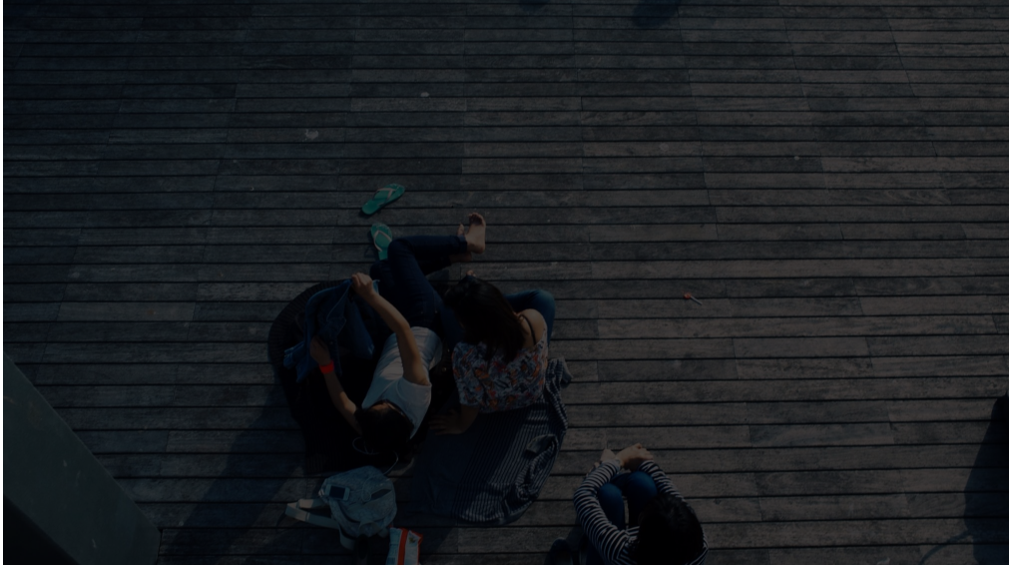

Today we are at the peak of psychoactive substances consumption in human history.

People with a genetic predisposition to suffer certain mental health issues have a significantly greater chance to develop the disorder